Project Development Phase
Model Performance Test

Date | 03 October 2026
Team ID | SWTID-2026-5003
Project Name | Implement Client Script and UI Policy (Incident)
Maximum Marks | 10 Marks (as stated in source template)

Model Performance Testing:
Prepared for the project team. The report uses available configuration screenshots; no formal performance measurements or signed test results were supplied. Team: Kaleeswari G (Team Leader: Milestones 4 and 5, Milestone 6 Activity 1); Devibala. A. S (Milestones 1 to 3); Karthika. M (Milestone 6 Activities 2 to 4); Amirtha Varshini S (Milestone 6 Activity 5 and conclusion).
S.No. | Parameter | Values | Screenshot
1. | Metrics | Regression metrics (MAE, MSE, RMSE, R²) and classification metrics (confusion matrix, accuracy, classification report) are not applicable: no ML model or dataset is part of this project. | 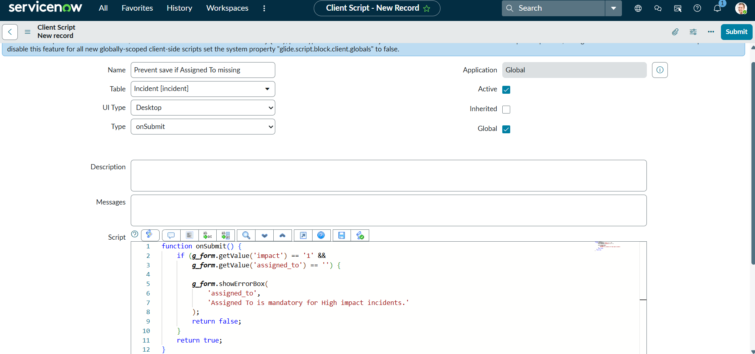
2. | Tune the Model | Hyperparameter tuning and validation method: not applicable; the project uses manually configured ServiceNow UI Policies and Client Scripts. | 